This is a sample of testing session as performed by a tester using Rapid Reporter.

You will notice that there is minimum tinkering with notes while the session happens. At the same time, the reporting mechanism is very powerful.

In order to keep familiarity, we used Jonathan Bach’s instructive session report ([*link*](http://www.satisfice.com/sbtm/demo/reports/sessions/et-jsb-010417-c.ses)) on the DecideRight software (*which I think is this:* [*http://www.skyhunter.com/dr.html*](http://www.skyhunter.com/dr.html)). DecideRight is a decision support and analysis tool, and we’ll follow Jon’s footsteps on his session.

**0)** It is recommended to have one folder for your project, and run from there. All the logs and files are collected in the folder Rapid Reporter runs from.

**1)** Tester name and charter description:





**2)** Add information about the setup being used:



**3)** Describe the mthods used to achieve the charter



**4)** Start describing tests and bugs…



**5)** Extended notes can be used, between other things, to describe reproduction steps of a bug.

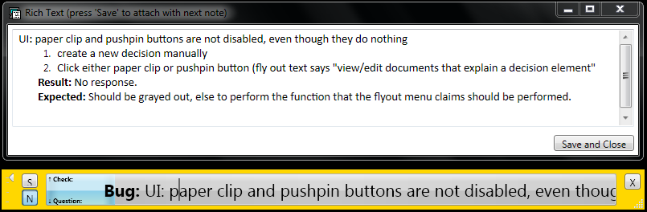

**

**6)** Pay attention to the decorated symbol in the [S] button – a screenshot was added as attachment.

**

**7)** This is what the screenshot looks like, a picture of the whole screen:

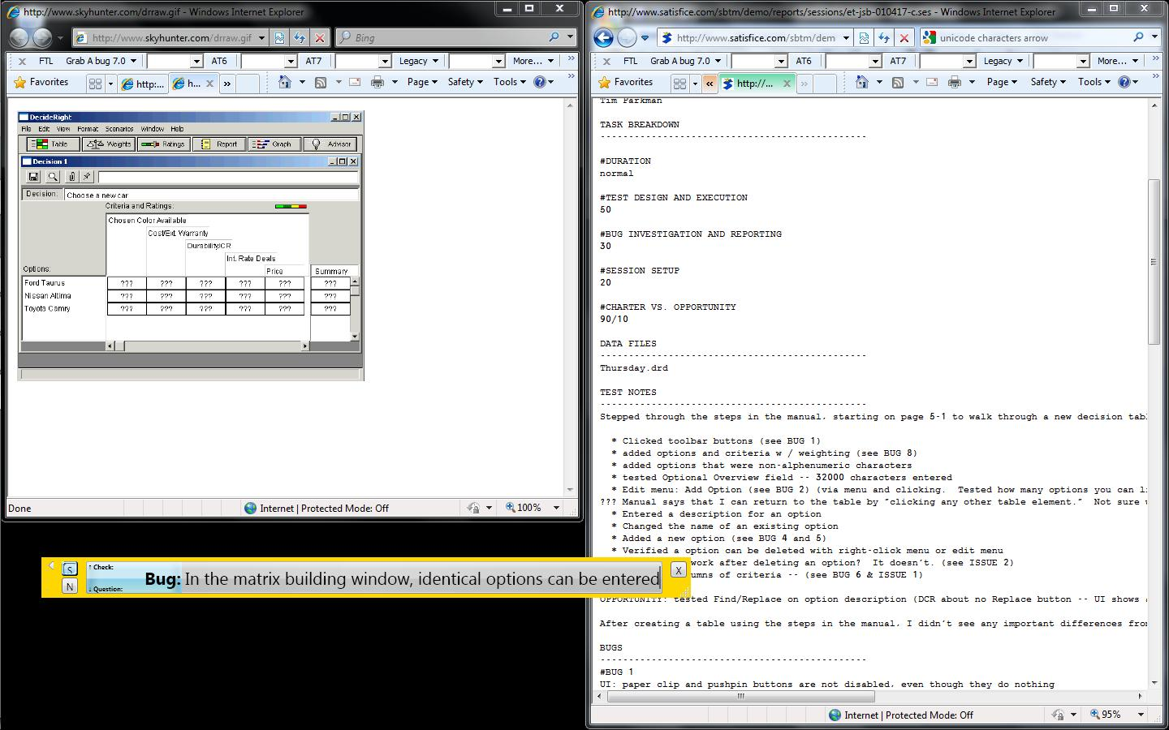

**8)** Continue with testing…







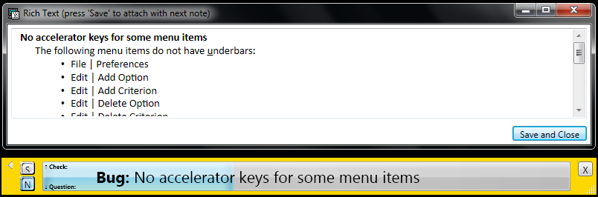

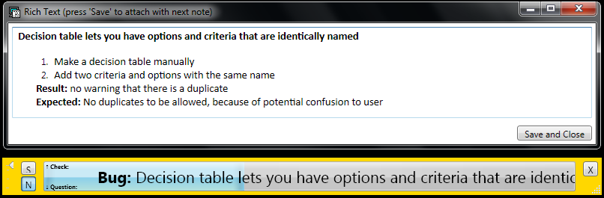

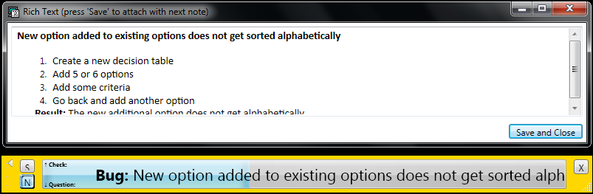

**9)** Questions or notes for next sessions can be filled as well

**

**

**

**

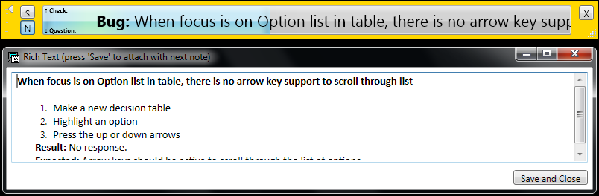

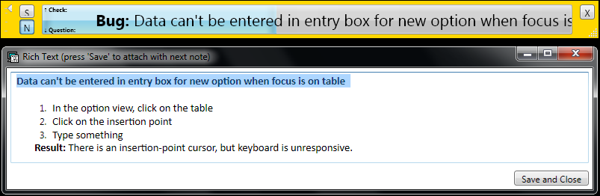

**

**

**

**

**

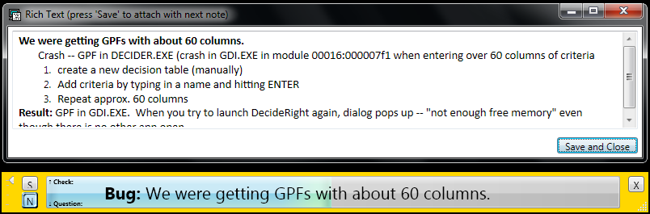

**10)** The report is text based:

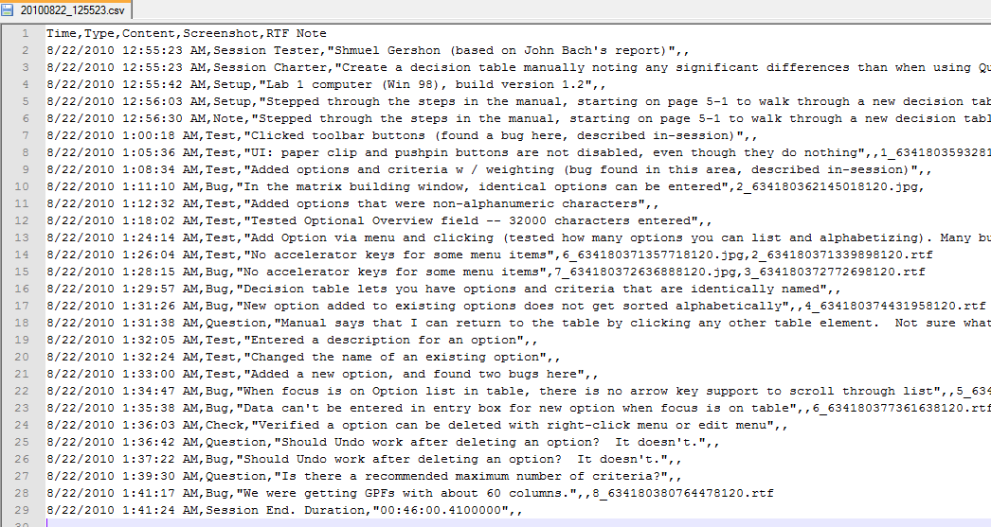

**11)** How the report looks like in Excel

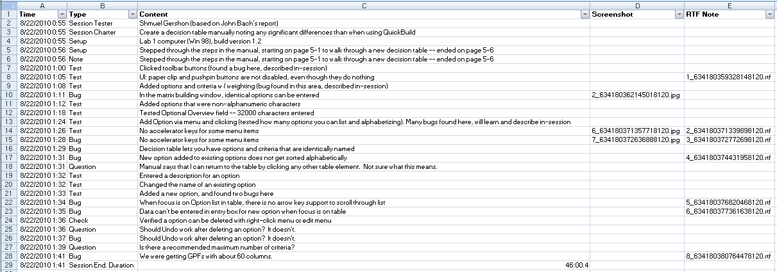

**12)** Filter or sort by type:

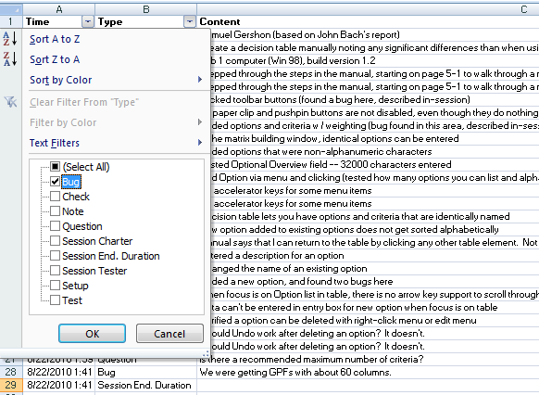

**13)** And look at the attachments of each entry:

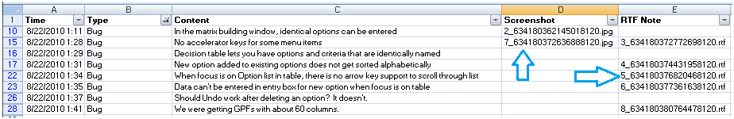

**14)** Image attachments are JPEG screenshots of whole screen (*works with multiple monitors*):



**15)** RTF Attachments are normal RTF documents, can be opened in Word/OpenOffice/Google Docs:

